Infra-red Toggle Switch for Home Appliances
Rajendra Bhatt
Introduction

The infra-red (IR) toggle switch project described here is aimed to provide control mechanism for electrical appliances that do not have remote operation features. The goal is to construct a black box where you can plug-in your 120V AC appliance and control ON and OFF operations with any modern IR remote control devices.

Modern IR remote controls generate modulated pulse train of 38KHz frequency when any key on the remote is pressed. With the use of capacitive filtering we will convert the stream of pulses into one pulse regardless of the key entered. This way, we will be able to toggle a relay switch with any key pressed on the remote. This project has been tested with varieties of IR remote control devices like that for TV, DVD, digital camera, etc., and it worked well.

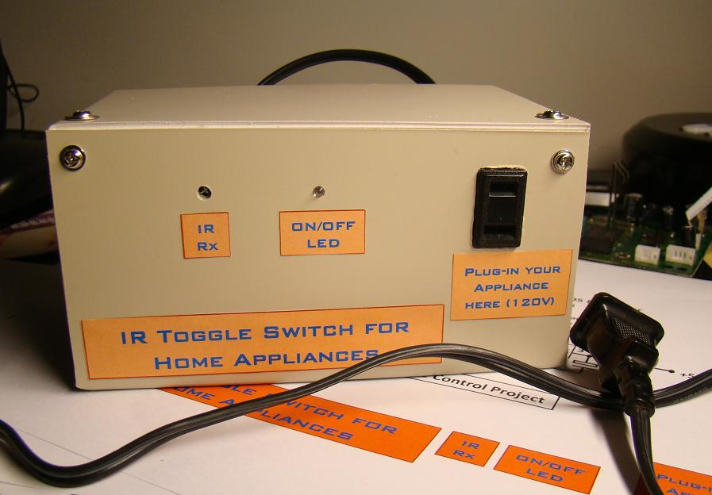
My IR toggle switch enclosed inside a box

Circuit Diagram

The TSOP 1738 IR receiver module detects the 38KHz input pulses received from the IR remote control device. Under stand-by condition, the output pin of the IR module is at logic High, and when it detects the train of pulses, they appear at its output. The output from IR receiver is fed to a PNP transistor (BC557) with a series base resistor of 4.7K. At the collector of the NPN transistor, the train of pulses will be inverted. There is a 10uF capacitor and 100K resistor connected from the collector to ground. The function of capacitor is to convert the train of pulses into a single pulse, and the resistor is to provide the discharge path for the capacitor.

So lets see what happens when a key on the remote is pressed. During standby, the output of IR receiver module is High, so BC557 is cut off. The capacitor is fully discharged, and the collector of BC557 is at ground. When a key is pressed on the remote, the train of pulses arrived at the base of BC557 turns it ON and OFF very fast. When it is ON, the capacitor gets charged through the collector current of BC557, and when it is OFF, the capacitor starts to discharge through 100K resistor. But the train of pulses is so fast (38000 pulses per second) that the capacitor doesn't get chance to discharge. So, the bottom line is, every time a key is pressed from the IR remote, a positive going clock pulse is generated at the collector of BC557 transistor.
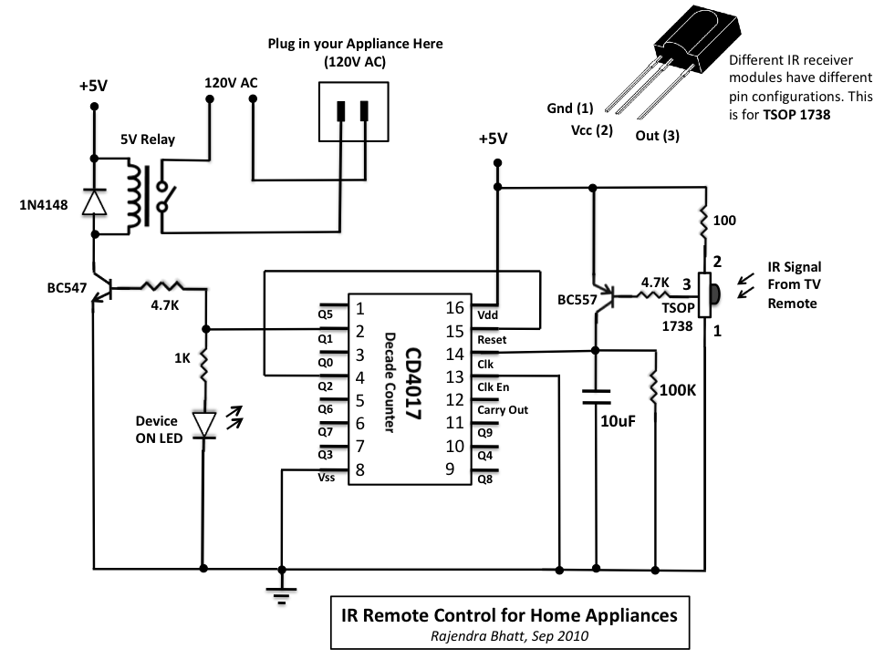
Next comes CD4017, a decade counter. It counts low-to-high going pulses up to 10 that are arrived at its CLK pin (14) and pulls the corresponding output (Q0-Q9) High. When it is just turned on, Q0 goes High, and when it gets a first low-to-high pulse (when a key is pressed from the IR remote) at CLK i/p, Q0 goes Low and Q1 goes High. Q1 output is connected to a LED through a current limiting resistor to indicate the ON/OFF status. The Q1 output is also used to drive a relay switch through a NPN transistor (BC547). I used 5V DC relay that requires about 70mA current from 5V source to turn ON. This current is provided by BC547.

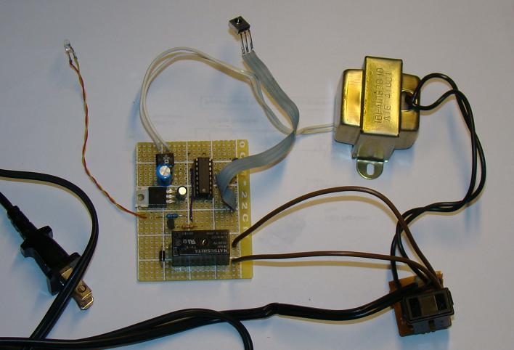
Complete circuit before putting inside the box.

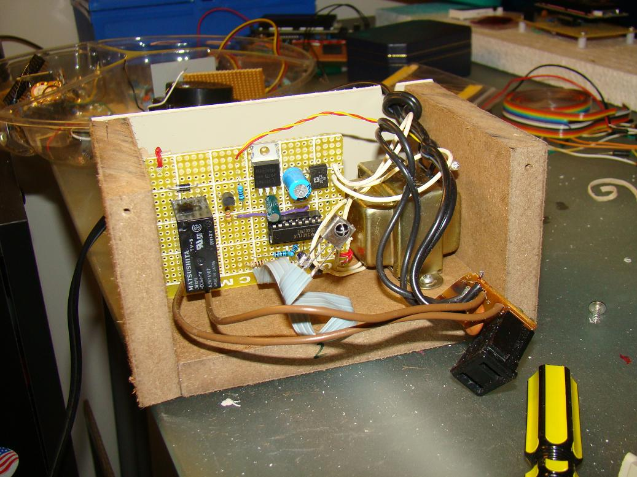
Packing inside a box for safety as it deals with 120V AC.

Now, lets see what happens when a key is pressed again. The counter advances by 1, Q1 goes Low (relay is OFF), and Q2 goes High. If we connect Q2 to Reset input of CD4017, the counter is going back to the initial condition (Q0 High, Q1 and all others Low), and is ready to get another key press signal to turn the relay ON. This way the switch is toggled every time a key is pressed from the remote.

Power Supply

The power supply for the circuit is provided through a 5V regulator IC LM7805. A 12V step-down transformer with a bridge rectifier and a capacitor filter provides an unregulated DC input to LM7805. The regulator IC provides a constant 5V supply for the circuit.
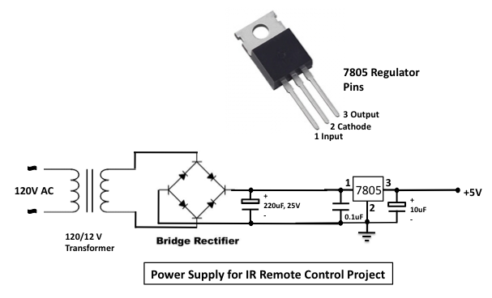
Be careful on the output side of the relay that connects to 120V AC line. A reversed biased diode parallel to the relay input is for back emf protection.

Switch in Operation
Below are some snapshots showing the IR toggle switch in operation.
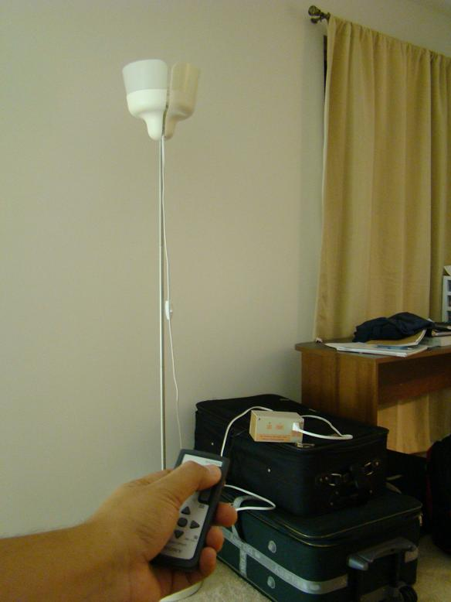
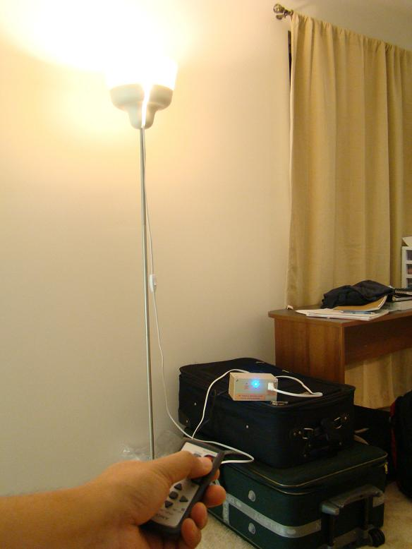
Device OFF Device ON

