Gás Detector Project

Introduction:

This is a gas detecting circuit capable of sensing many different types of gases.

The sensor used is the GH-312 and from the datasheet it is capable of sensing gases like smoke, liquefied gas, butane and propane, Methane, alcohol, hydrogen, etc.

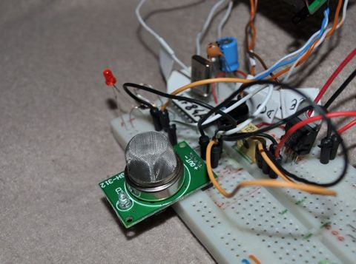

Schematic:

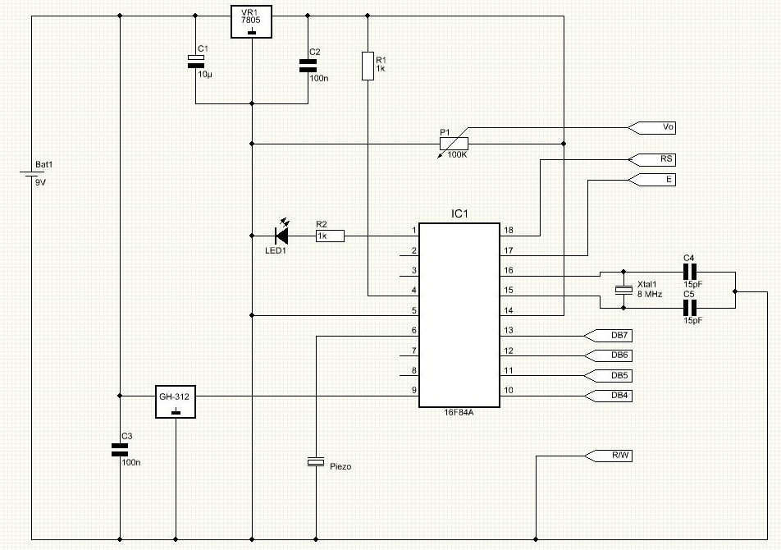

Part List:

R1 1K resistor
R2 1K resistor
P1 100K potentiometer
C1 10uF cap
C2 100nF cap
C3 100nF cap
C4 15pF cap
C5 15pF cap
Xtal 8Mhz crystal
Led1 3mm red led
Piezo Piezo
LCD 8X2 LCD
IC1 16F84A microcontroller
VR1 7805 regulator
GH-312 Gas Sensor

PCB:

The PCB used for this Project is single layer and its size is 65.95mm x 59.25mm.

Top Side

Here is the top view with the components

Bottom Side

Here’s the bottom side.

I’ve used a 9V battery for this project because the sensor requires a 9V input.

The output when the sensor is triggered is always 5V which is perfect for a direct connection to any microcontroller.

Although I’ve used a 9V battery, any 12V power supply ( a small wall transformer for example ) will work perfectly since the sensor can handle from 9V up to 20V and the microcontroller’s voltage is regulated by a 7805 regulator.

Testing:

The first tests were made with the circuit mounted on a breadboard.

After initialization the circuit will enter a normal state where it detects no gas.
The display shows "Sensing...No Gas !”.

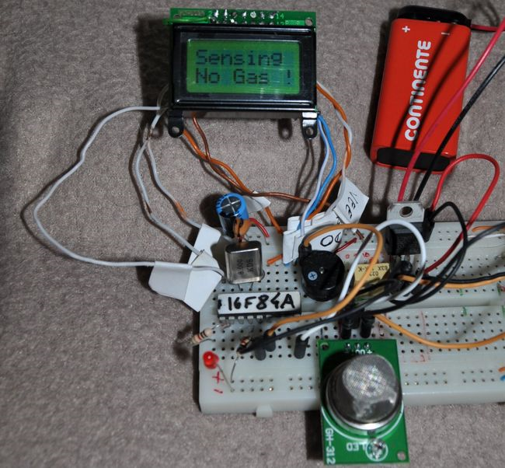

To test the sensor I used my portable gas soldering iron with the gas coming out pointed to the sensor.
The sensor is able to detect the gas and the microcontroller will trigger a flashing led warning and sound.
The sound is produced by a small piezo and the display show the message "Found Gas".
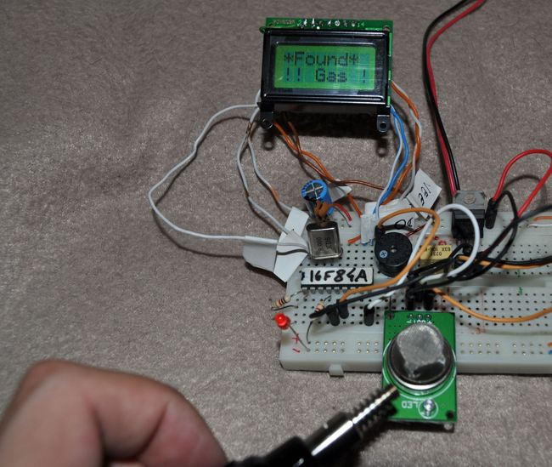

When the air is clean again and the sensor does not sense any gas, the circuit will return to it's normal state turning off both led and piezo sound.

Conclusion:

It's a pretty cheap and easy to assemble circuit.
Does not require too many parts and the microcontroller is very easy to find ( the famous 16F84A from microchip ).
Since it’s used a small lcd ( 8x2 ) this project can be portable.
Also this sensor senses several types of gas and it’s pretty stable.

